Y8 RE Common Homework 10 Vocation
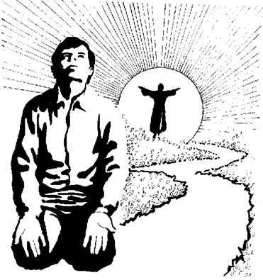

Task: Research a famous character from history or from modern society who has followed their vocation. This can include Christian vocation. Use internet sources wisely and do not cut and paste large sections of text from internet websites, as this will lose you marks.

Make sure you explain:
- WHAT this person’s vocation was/is,
- WHAT they did with their gifts and talents.
- HOW they achieved success and note any sacrifices they had to make along the way.
- Explain how this person has used their gifts and talents in order to serve others.

Some examples you may want to look at are: Florence Nightingale, Charles Darwin, Edith Cavell, John Henry Newman, Mother Teresa of Calcutta.

You may use the writing frame below to help you if you need it.

- The person I have chosen as an example of vocation is……………..
- I chose him/ her because…………………………..
- His/her life was extraordinary because………………………
- His/her gifts and talents were……………………………………..
- He/She faced opposition when…………………………………….
- An example of how she/he made a difference to the world is…………………………………
- He/she is a good example to others of how to follow a vocation, because……………..
- The thing I most admire about him/her is…………………
- The most important thing I have learned from this person for my own life is…………………………..

Remember,
  - Use your class work
  - Take pride in the way that you set out your work
  - Meet the deadline set by your teacher

Good luck and have fun!

